## Front End Engineering-II

Project Report

Semester-IV (Batch-2022)

ClickCove - Ecommece Website

AI Integrated

**Supervised By: Submitted By:**

Jaskirat Singh - 2210990446

Jatin Jaglan - 2210990458

Kartik Arora - 2210990486

Kartikey Bartwal - 22109904922

Dr. Baljit Kaur

Mr. Vikas Patel

**Department of Computer Science and Engineering**

## Chitkara University Institute of Engineering & Technology,

## Chitkara University, Punjab

|  |  |  |
| --- | --- | --- |
| **SR.NO.** | **SECTION** | **PAGE NO** |
| 1. | Introduction | 3 |
| 2. | Problem Definition | 4 |
| 3. | Proposed Design/Methodology | 5-7 |
| 4. | Result | 8-12 |
| 5. | Future Scope | 13 |

1. **Introduction:**

The e-commerce landscape is rapidly evolving, with businesses constantly seeking innovative solutions to streamline operations, enhance customer experiences, and drive growth. In response to this demand, our project endeavors to revolutionize e-commerce operations through the integration of cutting-edge machine learning (ML) techniques. By automating various facets of the e-commerce process, we aim to optimize efficiency, improve decision-making, and ultimately elevate the overall performance of online retail platforms.

* 1. **Background:**

The e-commerce industry has witnessed exponential growth in recent years, driven by advancements in technology and changing consumer behavior. Traditional e-commerce operations often rely on manual processes for tasks such as customer feedback analysis, product recommendation, and pricing optimization, which can be time-consuming and inefficient. The emergence of machine learning (ML) technologies presents an opportunity to automate and optimize various facets of e-commerce operations, revolutionizing the way online retail businesses operate.

* 1. **Objectives:**

The primary objective of this project is to develop an end-to-end machine learning system specifically tailored for e-commerce websites. The system aims to automate key processes such as sentiment analysis, product recommendation, pricing optimization, and customer churn prediction, thereby enhancing operational efficiency and driving business growth. By leveraging cutting-edge ML techniques, the project seeks to address common challenges faced by e-commerce businesses and empower them to deliver personalized experiences, maximize revenue, and improve customer satisfaction

* 1. **Significance:**

Automating e-commerce operations with machine learning holds immense significance for businesses, offering the potential to streamline processes, reduce costs, and gain a competitive edge in the market. By automating tasks such as sentiment analysis and product recommendation, businesses can gain valuable insights into customer preferences and behavior, enabling them to tailor offerings and marketing strategies accordingly. Furthermore, the implementation of dynamic pricing optimization and customer churn prediction models enables businesses to adapt to market dynamics and proactively address customer needs, fostering long-term relationships and loyalty

1. **Problem Definition and Requirements:**

**Problem Statement:**

Our project focuses on the development and implementation of an end-to-end machine learning system tailored specifically for e-commerce websites. The system comprises several distinct models, each designed to address specific challenges encountered in e-commerce operations. These models include:

**Software Requirements:**

Development Environment:

* Visual Studio Code (VS Code)
* Node.js and npm (Node Package Manager)

Front-end Technologies:

* React.js (JavaScript library for building user interfaces)
* HTML5 (Hypertext Markup Language)
* CSS3 (Cascading Style Sheets)
* TailwindCss
* JavaScript (Programming language for client-side functionality)

Back-end and Database:

* Firebase (Google's comprehensive app development platform, including cloud functions, authentication, hosting, and Firestore database)

Additional Libraries and Frameworks:

* React Router (For handling client-side routing in React applications)
* Other relevant libraries and frameworks based on specific features and requirements

Development Tools:

* Git (Version control system)

1. **Proposed Design and Methodology:**

**Modular Approach:**

To ensure a robust, scalable, and maintainable frontend for the e-commerce platform with AI integration, we will adopt a modular approach. This involves breaking down the application into distinct, reusable components, each responsible for a specific piece of functionality. Here is a detailed overview of the proposed design and methodology:

**3.1 Project Overview**

Project Title: AI-Integrated E-commerce Platform

**Technologies Used:**

* Frontend Framework: React
* Styling: Tailwind CSS
* AI Integration: Various AI services and libraries (e.g., TensorFlow.js, GPT-4 APIs)
* Build Tool: Vite or Create React App (CRA)
* State Management: Redux or Context API

**3.2 Modular Components**

The project will be divided into the following major modules:

User Interface Components:

* Header and Navigation: A responsive header with navigation links, a search bar, and user account access.
* Footer: Contains contact information, social media links, and additional navigation.
* Product Listings: Display products with filtering, sorting, and pagination features.
* Product Detail Page: Shows detailed information about a product, including AI-generated recommendations.
* Cart and Checkout: Manages user’s cart and handles the checkout process.
* Authentication and User Management:
* Login and Registration Forms: Secure forms for user authentication.
* Profile Management: Allows users to update their profile and view order history.
* AI Integration Modules:
* Product Recommendations: Suggests products based on user behavior and preferences using AI algorithms.
* Chatbot: An AI-driven chatbot for customer support and queries.
* Search Enhancements: AI-powered search functionality to improve relevance and accuracy of search results.
* Utility Components:
* API Services: Handles communication with the backend server and third-party APIs.
* Form Handling and Validation: Custom hooks and components for form management.
* Loading and Error Handling: Components to manage loading states and display error messages.

**3.3 Design Principles**

* Component Reusability: Each component should be reusable across different parts of the application to minimize redundancy.
* Separation of Concerns: Clearly separate UI components, state management, and business logic.
* Responsiveness: Ensure that all components are fully responsive and provide a seamless experience across different devices and screen sizes.
* Accessibility: Adhere to accessibility standards to make the application usable for all users.

**3.4 Methodology**

To ensure an organized and efficient development process, we will follow an agile methodology, with iterative development cycles and continuous feedback integration. Below is the step-by-step methodology for the project:

1. **Planning and Requirements Gathering:**

* Define project scope, objectives, and deliverables.
* Identify key functionalities and features to be developed.
* Create user stories and acceptance criteria.

1. **Architecture and Design:**

* Design the overall architecture of the application.
* Create wireframes and prototypes for key components and pages.
* Define the data flow and state management strategy.

1. **Setup and Configuration:**

* Initialize the React project using Vite or Create React App.
* Configure Tailwind CSS for styling.
* Set up Redux or Context API for state management.

1. **Component Development:**

**UI Components:**

* Develop the header, footer, and navigation components.
* Create the product listings and detail pages.
* Implement the cart and checkout components.

**Authentication:**

* Build the login, registration, and profile management components.

**AI Integration:**

* Integrate product recommendation algorithms.
* Implement the AI-powered chatbot.
* Enhance the search functionality with AI.

1. **Styling and Responsiveness:**

* Apply Tailwind CSS to style components.
* Ensure responsiveness across all devices.
* Conduct usability testing to refine UI/UX.

1. **Testing and Quality Assurance:**

* Write unit tests for individual components.
* Perform integration testing to ensure components work together.
* Conduct end-to-end testing for the entire application.
* Fix bugs and optimize performance.

1. **Deployment and Maintenance:**

* Deploy the application to a staging environment for final testing.
* Deploy to production using a reliable hosting service.
* Monitor application performance and user feedback.
* Regularly update the application with new features and improvements.

**3.5 Tools and Technologies**

**Development Tools:**

* Code Editor: Visual Studio Code
* Version Control: Git and GitHub
* Build Tools: Vite or Create React App

**Testing Tools:**

* Unit Testing: Jest and React Testing Library
* Integration Testing: Cypress or Selenium
* Performance Monitoring: Lighthouse, Google Analytics

**Deployment:**

* Hosting: Vercel, Netlify, or AWS Amplify
* CI/CD: GitHub Actions, Travis CI

**3.6 Workflow and Collaboration**

**Agile Sprints:**

* Plan and execute development in 2-week sprints.
* Hold daily stand-up meetings for progress updates.
* Conduct sprint reviews and retrospectives.

**Collaboration Tools:**

* Project Management: Jira or Trello
* Communication: Slack or Microsoft Teams
* Documentation: Confluence or Notion

By following this modular approach and agile methodology, we aim to build a highly functional, scalable, and user-friendly e-commerce platform that leverages the power of AI to enhance the shopping experience.

1. **Results:**

**Architecture of Website:**

The AI-Integrated E-commerce Platform uses a component-based frontend built with React and Tailwind CSS, managed by Redux or Context API, and communicates with a Node.js backend via RESTful APIs or GraphQL, integrating AI services for recommendations and chatbots, all deployed using Vercel or Netlify with continuous integration and security best practices.

1. **Signup**

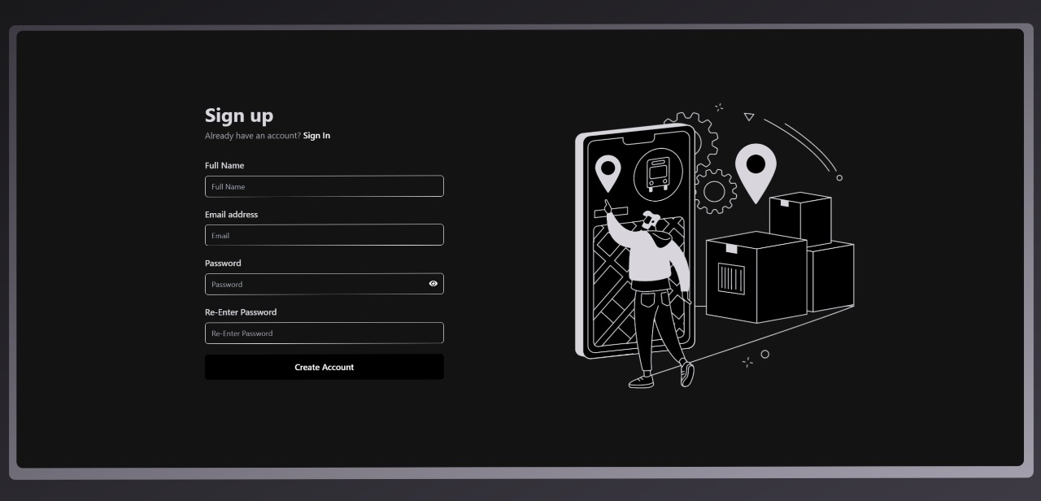

1. **Login**

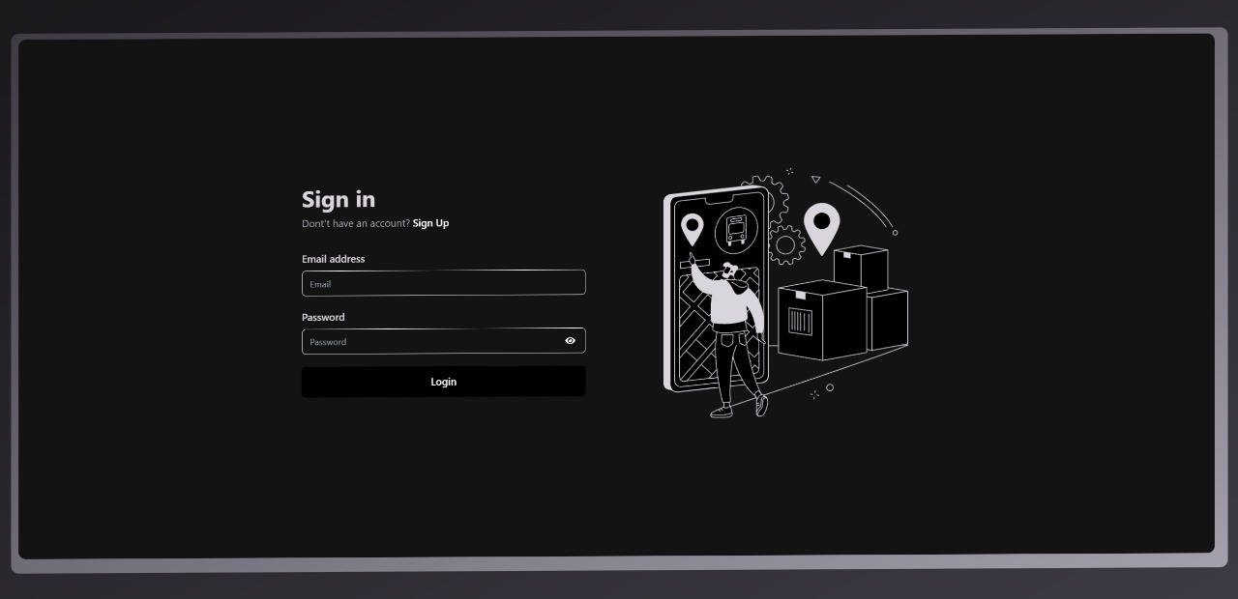

1. **Landing Page**

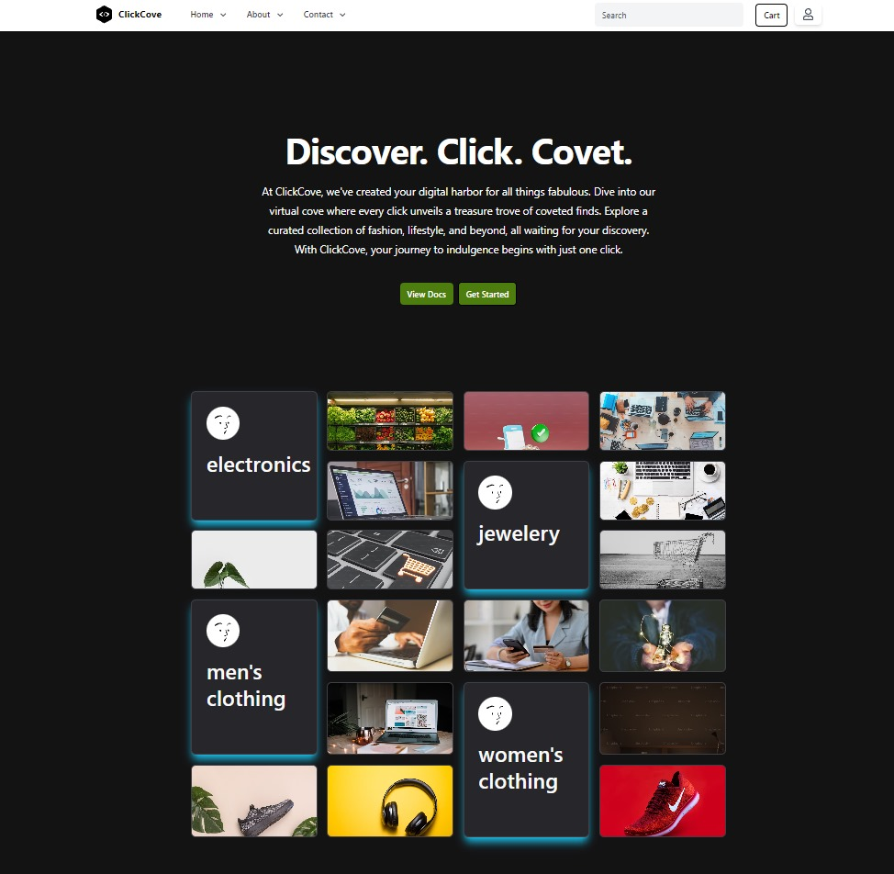

1. **Products**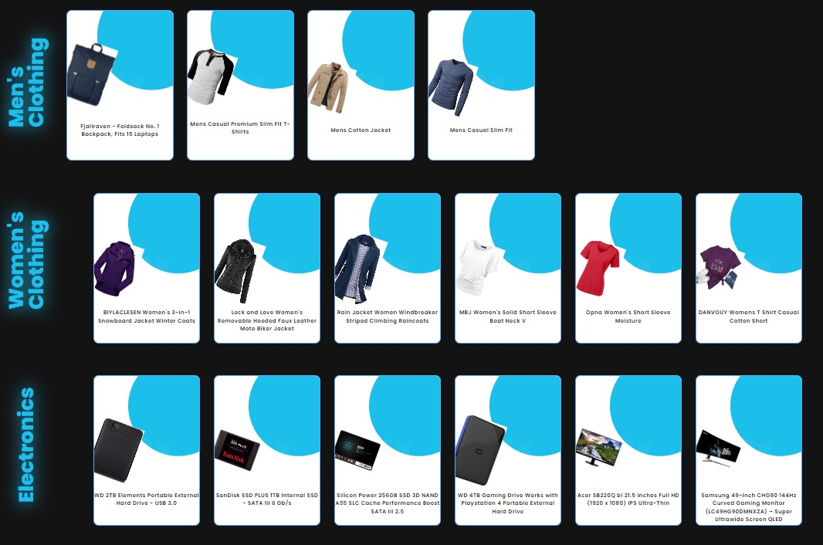
2. **Product Preview**

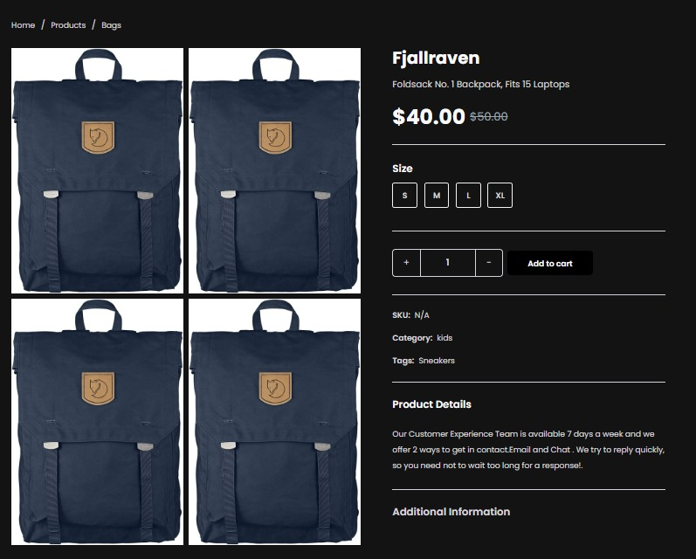

* 1. **Future Scope:**
* Advanced AI Recommendations: Enhance algorithms for personalized product suggestions and real-time adjustments based on user behavior.
* Voice and Visual Search: Integrate voice recognition for search functionality and develop visual search capabilities using image uploads.
* Augmented Reality (AR): Implement AR features for virtual try-ons and product visualization in users' environments.
* Dynamic Pricing and Promotions: Use AI to implement dynamic pricing strategies and offer personalized discounts and promotions.
* Multilingual and Multi-Currency Support: Expand to support multiple languages and currencies, including automatic translation and conversion.
* Vendor and Marketplace Integration: Enable third-party vendors to list products, creating a comprehensive marketplace ecosystem.
* Enhanced Security and Analytics: Continuously improve security measures, implement AI-driven threat detection, and develop advanced analytics dashboards for monitoring sales and user behavior.